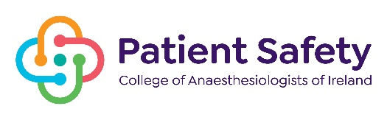
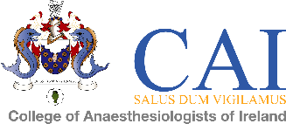

COLLEGE OF anaesthesiologists OF IRELAND
In association with
NATIONAL PATIENT SAFETY IN ANAESTHESIA CONFERENCE

KP Moore Medal Competition - Friday 6th November 2026

ABSTRACT FORM

TITLE:

AUTHOR (S):

PRESENTER:

NAME & ADDRESS OF INSTITUTION:

Mobile Number:

Email:

Consultant:

Abstracts to include description of study methods, results and conclusions - Maximum 250 words.

Closing date for submission of abstract Monday 14th of September 2026 at 4.00 pm.
Please submit the abstract online here

Please write abstract here:

