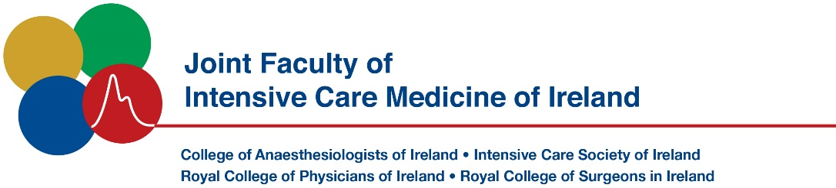

|  |  |
| --- | --- |
| **Name of meeting:** | Irish Donor Awareness Programme IDAP |
|  | Fri 9th May 2025 Virtual Meeting Via Zoom |

## Course Fee €75 (Registration is free for FJFICMI exam candidates)

|  |  |  |  |
| --- | --- | --- | --- |
| **Surname:** |  | **Forename:** |  |

|  |  |
| --- | --- |
| **Address:** |  |

|  |  |
| --- | --- |
|  |  |

|  |  |
| --- | --- |
|  |  |

|  |
| --- |
|  |

|  |  |
| --- | --- |
| **Contact Number /**  **Email address:** | +353 _________________________________ |

**\*Payment will be taken via a virtual portal that will be emailed to you in advance of course commencement.**

Please return completed application form to [jficmi@coa.ie](mailto:jficmi@coa.ie)