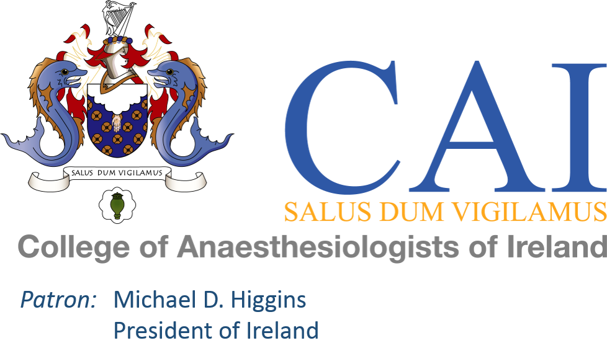

EXPENSE CLAIM FORM
(Attach receipts to support your claim)

Name: |  | PPS No.

Address:

Reason for Travel:

TRAVEL (see reverse for college policy)
Point of departure:

Destination

Date (s):

Method of Travel: Bus |  | Luas |  | Taxi |  | Train |  | Air |  | Own Car |  |  | Air |  | Air

Reason for using car:

Mileage Claimed ___________Kilometres

Please see Policy on travel related to College of Anaesthesiologists of Ireland business for Car Mileage Rates
Mileage is capped at the price of a first class train ticket from your departure point.

Misc. expenses

Description of Misc. Expense 1

Description of Misc. Expense 2:

Claim Total: | € | £

Signature of Claimant: _________________________________
Date of Claim: |  | / |  | /

Please submit all expenses with receipts within three months.

Payment Information Request Form
Name:
Address:
E-mail:
Phone No:
PPS Number:
Bank Details:
Sort Code:
Account No:
BIC Code:
IBAN:
Bank Address:
Signature:
Please Submit Form to the Finance Office
E-mail: finance@coa.ie
Phone: 01 265 0616

Policy on travel related to College of Anaesthesiologists of Ireland business

Train - First Class train fare will be reimbursed

Car - Civil Service rates as paid, as per table below (valid since September 2022):

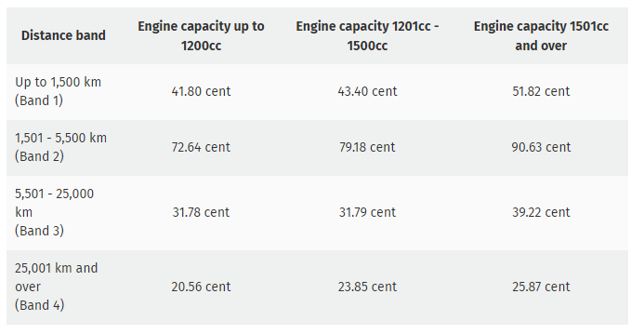
Mileage claims made in respect of journeys carried out in electric vehicles should
use the rates applicable to engine capacity 1201cc-1500cc (as per above table)

Air - Economy rate should be used

Air travel should be booked early to avail of best rates.

Business class fares will not be covered unless by prior agreement with the President and Honorary Treasurer.

