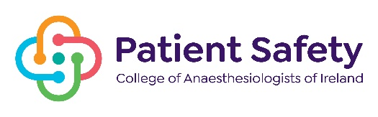
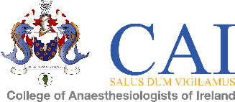

COLLEGE OF anaesthesiologists OF IRELAND
In association with
NATIONAL PATIENT SAFETY IN ANAESTHESIA CONFERENCE

KP Moore Medal Competition - Friday 17th November 2022

ABSTRACT FORM

TITLE: | Quality improvement project to modify the management of neuromuscular blockade and reduce postoperative morbidity and mortality in Letterkenny University Hospital

AUTHOR (S): | Rumbidzai Tsomondo, Netsai Chikosi

PRESENTER: | Rumbdizai Tsomondo, Netsai Chikosi

NAME & ADDRESS OF INSTITUTION: | Letterkenny university hospital  Kilmcrennan Rd, Ballyboe Glencar, Letterkenny, Co. Donegal F92AE81

Mobile Number: | 0830825407, 0874389743

Email: | natsierue@gmail.com, rumbidzai.tsomondo@gmail.com

Consultant: Dr Lori Dippenaar

Abbreviations
LUH- Letterkenny university hospital
NMBA -neuromuscular block agents
NMB- neuromuscular blockade
TOF- Train-Of-Monitoring
GA- General Anaesthesia
AAGBI- Association of Anesthetists of Great Britain and Ireland
QIP- Quality Improvement Project

Introduction
Inadequate reversal of neuromuscular blockade has a multifactorial negative impact on the patient’s peri-operative experience. It may be characterized by an increased risk of iatrogenic post-operative pulmonary complications, accidental awareness and associated risk of prolonged hospital stay thus increasing the morbidity and mortality associated with anaesthesia.

Aim
1. Audit the management of neuromuscular blockade at LUH between January and July 2023, assessing current clinical practise and adherence to the latest AAGBI guidelines on patient monitoring.
2. QIP to modify the practice of NMBA reversal in LUH anaesthesia department by instituting standard use of quantitative TOF monitoring on all patients thereby reducing perioperative risk and delivery of a safer anaesthetic.

Methodology
In total, LUH had approximately 1786 patients undergo surgical procedures under GA between January 2023 -July 2023. We randomly selected 772 files and conducted a retrospective study on 320 cases that fit our sample criteria.

Results
The probability of a general anaesthetic being conducted with an endotracheal tube vs supraglottic airway was 1:1.35 in favour of the SGA. Approximately 42% of patients received a neuromuscular blocker; with only 4% of those patients receiving TOF monitoring. The adverse events associated with residual blockade in our population are unknown.

Conclusion
Qualitative neuromuscular analysis and clinical signs of reversal which are neither sensitive nor specific markers are the current standard of practise at LUH. Quantitative neuromuscular monitoring in every phase of anaesthesia guides the optimum timing of reversal and dosing of the antagonist which is noted to be until recovery of the TOF >0.9 . Initiation of quantitative monitoring as standard practice in LUH will improve patient safety through reduction of the risk of post-operative pulmonary complications in approximately 42% of patient that undergo GA thus reducing morbidity and mortality.

