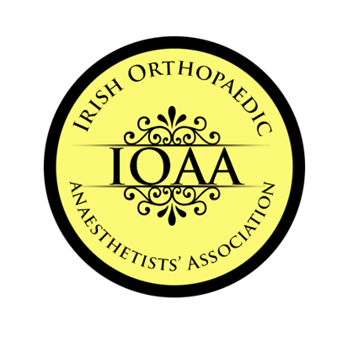
Please complete this form in BLOCK CAPITALS & return to:

ioaameeting@gmail.com

Name of meeting: | Irish Orthopaedic Anaesthetists’ Association 25th November 2022, College of Anaesthesiologists

Registration Fee: €175 | Includes coffees, lunch &post event drinks at Cellar Bar and dinner in Bang, Merrion Row | Dinner Yes/No

Surname: |  | Forename 1:

Address line 1:

Address line 2:

Address line 3:

Email address:

Present appointment and hospital:

Payment:
CASH (on day) please note no credit/debit card facilities are available
CHEQUE (on day) made payable to IOAA
BANK TRANSFER
Account name: Cappagh National Orthopaedic Hospital
Sort Code 90-05-51 39458115 Bank of Ireland Finglas Dublin 11
IBAN IE13 BOFI 9005 5139 4581 15
BIC BOFI IE 2D
Please put your name as reference

