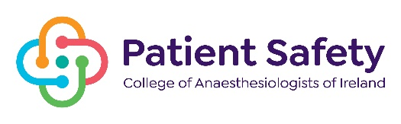
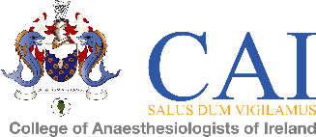

COLLEGE OF anaesthesiologists OF IRELAND
In association with
NATIONAL PATIENT SAFETY IN ANAESTHESIA CONFERENCE

KP Moore Medal Competition - Friday 11th November 2022
22 Merrion Sq North & Virtual Conference

ABSTRACT FORM

TITLE:

AUTHOR (S):

PRESENTER:

NAME & ADDRESS OF INSTITUTION:

Mobile Number:

Email:

Abstracts to include description of study methods, results and conclusions - Maximum 250 words.

Closing date for submission of abstract Monday 17th, October 2022 at 4pm.
Please submit the abstract online here

Please write abstract here:

