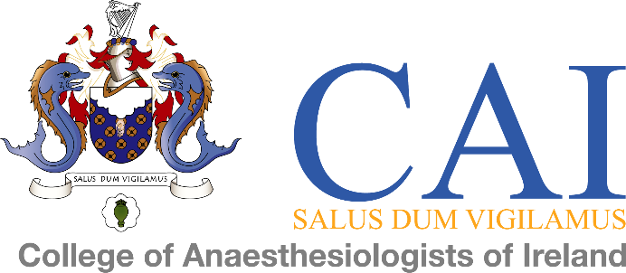

In preparation for your exams being administered online and being proctored/invigilated online, there are 2 items of documentation that you are required to sign and submit (see below):

- Honour Pledge to declare that you are completing your examination without help. The full text of the declaration is below.

- Consent Form for the additional data that is being collected due to the online proctoring. The College of Anaesthesiologists requires this consent because additional personal data is collected during the online proctoring which is not required in regular examination procedures. The provisions of the General Data Protection Regulation (GDPR) apply to the storage and processing of data.

The deadline for submission of these documents to the Examinations Department info@coa.ie is 17:00 Friday 13 November 2020.

We would like to wish you the very best of luck in your exams and remind you to keep safe.

Honour Pledge

“I confirm that I will complete my Membership CAI MCQ examination without the help or input of any other person or resources during the examination time and that the answers I submit will be my own. I acknowledge that I may be invited to an online interview with the College, if there is any concern in relation to the integrity of my exams.”

Full Name:

Signature:

Date:

Proctoring Consent

The College of Anaesthesiologists of Ireland (CAI), offers you the opportunity to take part in remotely monitored online examinations. In this case, you can take an online exam directly from home. In addition to the data protection information (processing in accordance with EU-DSGVO/GDPR³ article 6(1)(b),(c) and (f) - https://gdpr-info.eu/art-6-gdpr/) in the study registration form you have signed, the College requires your consent to Online Proctoring (OP) of a regular examination (in e-testing format), because additional personal data is collected during the OP which is not required in regular examination procedures. The provisions of the General Data Protection Regulation (GDPR) apply to the storage and processing of data. This means that only authorized persons, i.e. examination office, examination board (in cases of doubt) have access to your examination session data.

Goal
The main purpose of the OP is to ensure a smooth examination process for both you and the College of Anaesthesiologists of Ireland i.e. the so-called Academic Integrity⁴. The aim of the collection of voice, video and photo recordings (data) is that a proctor (or supervisor or surveillance staff) can visually observe the identification of the candidate and the examination process to ensure that academic integrity is maintained. In addition to your first name, last name and e-mail address, data in the form of ID photos (prepared by you), screenshots, webcam photos, webcam video streams and, if applicable, smartphone video streams are digitally captured, stored and processed during the OP to fulfill the main purpose of the OP (see above). Otherwise, the same rules apply as in a normal on-site written examination. Violations of the rules (e.g. identity fraud, unauthorized aids, plagiarism, etc.) will be penalised in the same way as in an offline examination. Verified cheating disqualifies candidates from retaking the exam. Familiarize yourself with the rules and guidelines of the respective exam in our exam regulations on the College website.

Securing your own privacy
Before starting the OP process, you will be asked to prove your identity. The display of ID information (especially a passport photo) is required by law. Be aware that you are responsible for covering all unnecessary data (e.g. health or social security numbers) before taking a photograph.

Consent and Confirmation of “Clarification”
In order to take the online exam, The CAI requires proof of clarification and your consent. By participating in the remote monitoring of your examination, you confirm that you have been informed about it, - that the monitoring is carried out by UK Company Fry IT. - that parts of your passport (which are not covered) will be photographed and stored in order to verify your identity for verification. - that you will be asked to make a 360-degree video recording of the test environment in which you and your computer are located to be saved in order to ensure a proper test environment. - you and your screen are filmed throughout the exam and noises are recorded in the working environment. These recordings are saved so that you can later prove that you performed the exam properly.

My Proctoring Consent

"I understand that language, video and photo footage of me, my environment, my screen and my ID document will take place. These serve the purpose of monitoring my CAI examination required by law. These records will be stored on the servers of Fry IT until it has been confirmed that the exam has been completed properly. If irregularities occur or there is a suspicion of misuse, the records are transferred to a secure location on one of the institutionally approved storage media for personal data. The Exams Department and the Examination Board only have access to this data to verify that the examination rules have been followed.“
With regard to participation, the following points were clarified:
- I declare my consent to the above facts.
- I am aware that I can revoke this consent at any time for the future without giving reasons.
- I am aware that participation in this examination will then no longer be possible. The CAI Exams Regulations on www.anaesthesia.ie regulate how grading is to be handled.

Full Name:

Signature:

Date:

