Time | Topic | Speaker(s)
08:00 – 08:25 | Registration and Coffee
08:30 – 08:45 | Opening Address | Dr Brian Kinirons, CAI President &  Prof David Honan, Examinations Chair
08:45 – 09:45 | Exam Overview | Dr Basabjit Das, Pain Faculty  Dr Andrew Westbrook, JFICIM  Dr Leo Kevin, Membership Chair  Prof Michael Griffin, Fellowship Chair
09:45 – 10:15 | Overview of assessment/  introduction to psychometrics | Dr Gareth Morrison, Medical Educationalist
10:15 – 10:30 | Coffee
10:30 – 11:15 | Standard Setting  Voting system | Dr Helena McKeague, Medical Educationalist
11:15 – 12:15 | Parallel Sessions  - SAQ writing session  - Standard setting OSCEs | Prof Michael Griffin  Prof Richard Arnett, Director of Psychometrics, RCSI
12:15 – 13:00 | Lunch
13:00 – 13:30 | SBA | Dr Gareth Morrison
13:30 – 14:00 | SOE | Dr Deirdre McCoy, Examinations Committee
14:00 – 14:15 | Coffee
14:15 – 15:00 | Future Directions for Examinations at CAI  Round Table Discussion | Dr Criona Walsh, Medical Educationalist  Future of examinations processes
15:00 – 15:30 | Professionalism and Etiquette | Dr Leo Kevin
15:30 – 16:30 | Equality and Diversity | Ms Roisin Campbell  Ms Fionnula Delap  Medical Human Resources
16:30 | Close of Meeting followed by drinks reception | Prof David Honan
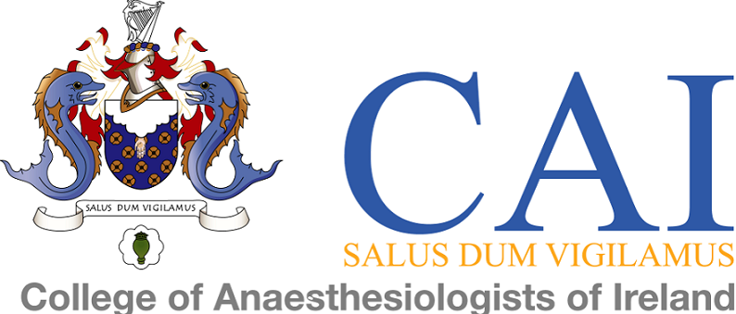

Examiners Training Day
Friday 31st January 2020

Venue: CAI, 22 Merrion Square North, Dublin 2

