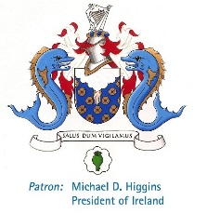
Please complete the form in block capitals or in typed formaT-photo’s of it cannot be processed
This form should be emailed to exams@coa.ie OR posted to: The College of Anaesthesiologists, 22 Merrion Square North, Dublin 2 with or after your application for the FCAI CLINICAL/SOE Examination of November 2019

Course Name: FCAI Final Revision Course-Tuesday, 12th November 2019
Registration Fee: €290
College ID: _______________
Date written exam passed: _______________
Name: _________________________ Surname: ____________________________________________
Address line 1: _____________________________________________________________________________________
Address line 2: _____________________________________________________________________________________
Address line 3: _____________________________________________________________________________________
Town/City: __________________________ Country: ____________________________________________
Mobile number (including country code): ____________________________________________
Email Address: _____________________________________________________________________________________

Current post and hospital: _____________________________________________________________________________
Dietary requirements: _____________________________________________________________________________

Payment can be made by euro cheque, made payable to The College of Anaesthesiologists of Ireland or by credit card (see below)
Please charge my credit card: Visa MasterCard Total Remittance:
Card number: |  |  |  |  | - |  |  |  |  | - |  |  |  |  |  | - |  |  |  |  |  |  | Expiry Date

Security Code: (last three numbers on the back of credit card)

Cardholder’s signature: ____________________ Cardholder’s Name: _______________________
Date: ____________________
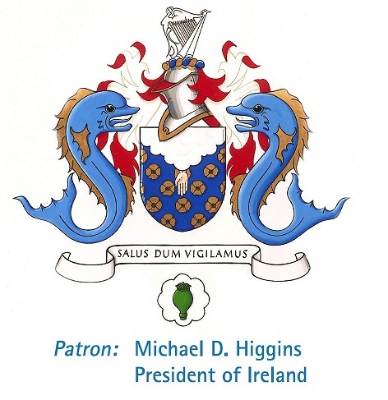

FCAI Final Revision Course

Date: Tuesday, 12th November 2019

Time: 8:30am to 4:30pm (approx.)

Venue: College of Anaesthesiologists of Ireland, 22 Merrion Square

Course Fee: €290 (includes lunch)

Availability: Early booking is advised as there are a limited number of places available.

Co-ordinator: Dr.Ehtesham Khan

Please note 50% of the course fee will be charged if written cancellation is received in the college more than 21 days prior to the course commencing. Delegates cancelling after this date will NOT be entitled to a refund unless the College considers there to be exceptional circumstances that would warrant a refund. All personal information provided to the College of Anaesthesiologists of Ireland (CAI) on this form is protected by data protection laws. This data is required for the administration of your course fee with CAI. Your credit/debit card details will not be retained by us subsequent to the processing of your payment. A record of the fee paid will be maintained by CAI. We take our responsibilities under the data protection laws very seriously. We will never disclose your personal data unless required to do so by legal or regulatory obligations. CAI takes all reasonable steps as required by law to ensure the safety, privacy and integrity of your personal information.

