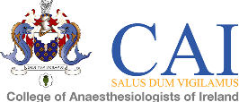

Please complete this form in BLOCK CAPITALS using BLACK INK
Return form to: The College of Anaesthesiologists of Ireland, 22 Merrion Square North, Dublin 2 or email to simulation@coa.ie

Name of meeting: | ADULT RETRIEVAL/TRANSFER SERVICE TRAINING DAY

Registration Fee: | €50.00

Surname: |  | Forename 1:

Address line 1:

Address line 2:

Town/City: |  | Country:

Telephone number

Email address:

FINANCE DEPARTMENT,The College of Anaesthetists of Ireland, 22 Merrion Square North, Dublin 2

Payment can be made by Euro cheque, made payable to The College of Anaesthesiologists of Ireland, or by credit card below:

Please charge my credit card: |  | Visa |  | MasterCard | Total Remittance:

Card number: |  |  |  |  | - |  |  |  |  | - |  |  |  |  | - |  |  |  |  |  |  | Expiry Date

Security Code: (last three numbers on the back of credit card)

Date:

Cardholder's signature: |  | Cardholder's name:

