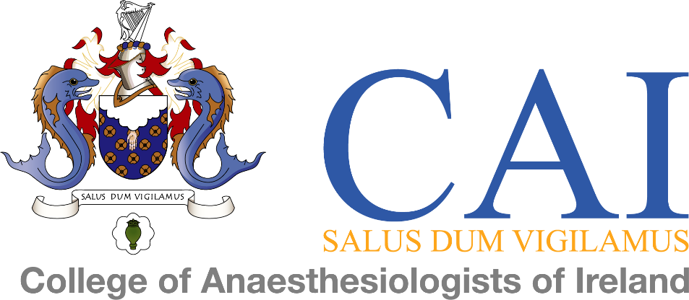

Hospitals Accredited for Training

The hospitals accredited for Specialist Anaesthesiology Training (SAT) for 2019
are listed below:

Eastern Region: Beaumont Hospital
Cappagh National Orthopaedic Hospital
Connolly Hospital Blanchardstown
Coombe Women and Infants University Hospital
Our Lady's Children's Hospital, Crumlin
Our Lady of Lourdes Hospital, Drogheda
Royal Victoria Eye and Ear Hospital, Dublin
National Maternity Hospital, Holles Street
Mater Misercordiae University Hospital
Midland Regional Hospital Mullingar
Rotunda Hospital
St James's Hospital
St Vincent's University Hospital
Tallaght University Hospital
Temple Street Children's University Hospital

Southern Region: Cork University Hospital
Mercy University Hospital, Cork
University Hospital Limerick
South Infirmary-Victoria Hospital, Cork
University Hospital Waterford
Wexford General Hospital

Western Region: Letterkenny University Hospital
Mayo General Hospital
Sligo University Hospital
University Hospital Galway

