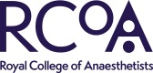
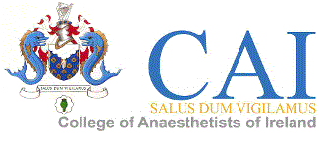
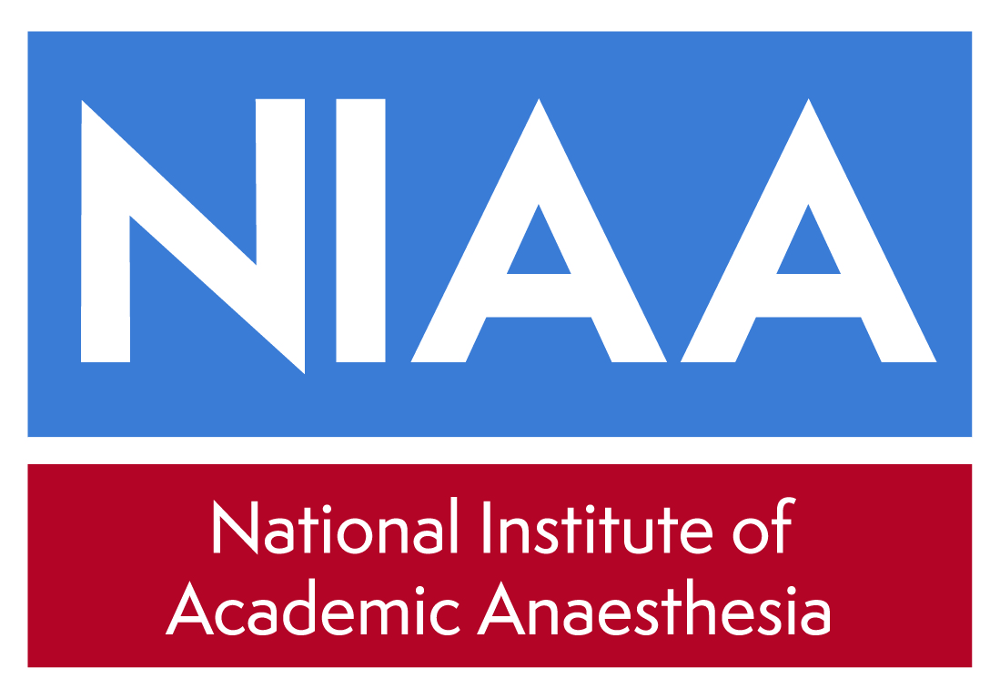
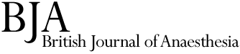

NATIONAL INSTITUTE OF ACADEMIC ANAESTHESIA
BJA/RCoA – CAI: Collaborative Research Grant Application Form - 2019
Up to €100K (~£89.5k) per grant

Summary

Principal Applicant (ROI/UK - to where the funding will be sent):

Address :

Telephone:

Fax:

E-mail:

Principal Applicant gender: Male ☐
Female ☐
Prefer not to declare ☐

Co-Applicant (Eire/UK):

Address :

Telephone:

Fax:

E-mail:

Names of any collaborators and Department(s) involved in the Project:

(Names, roles and affiliations)

Please indicate how many hours per week EACH collaborator will give to this project:

Institution administering the grant (UK or ROI):

Title of Project:

Abstract of the proposed project (up to 200 words):

Lay Abstract (up to 500 words; this forms an integral part of the submission and should be written in language understandable by an educated non-medical reader):

Proposed starting date: Estimated duration:

Please list other grants currently held in this area of research:

If the proposed grant is in the same area as one of the above, how does the work differ from that currently funded?

Applicants who have previously been successfully funded by the BJA (within the past 3 years) should report the progress on their previous grant here:

BJA/RCoA – CAI Collaborative Research Grant Application Form

- Please cost in £ and state the exchange rate you have used here__________; as appropriate.

Salaries (all include NI and superannuation where appropriate)
Where appropriate agreed NHS research costs should be included.

a. Research Staff
Grade:

Name:

Salary: Year 1

Year 2

Subtotal £

b. Technical Staff

Subtotal £

c. Apparatus

Subtotal £

d. Consumables and Other items

Subtotal £

TOTAL GRANT REQUESTED £

(Please include Superannuation, National Insurance and VAT where applicable).

NIHR Portfolio Adoption
Please note that unless you inform us that your study is suitable for NIHR portfolio adoption, applications for under £5,000 will be reviewed internally by the NIAA Grant Committee and will not be sent for external peer review.

If you intend to apply for portfolio support please could you confirm that here: Yes/No

BJA/RCoA - CAI Collaborative Research Grant Application Form: Regulations

1. Principal Applicant (ROI or UK)

“I understand and agree to comply with the conditions of the BJA/RCoA CAI Collaborative Research Grant. If successful, I will be involved directly in the proposed research project."

Name

Signature

Date

2. Head of Department for Principal Applicant

“I confirm that the details given in this application are correct. If successful, the grant will be administered in this department in accordance with the BJA/RCoA – CAI Collaborative Research Grant conditions."

Name

Address

Telephone/Fax

Signature

Date

3. Institution Administrative Officer for Principal Applicant

“I confirm that the details given in this application, including the staff gradings and salaries are correct. Where appropriate, NHS research costs have been agreed and included in the costings. If successful, the grant will be administered by this institution in accordance with the BJA/RCoA - CAI Collaborative Research Grant conditions. I accept that the BJA/RCoA - CAI will not contribute to any additional costs other than those specified in this form. I also agree that should any intellectual property rights or income accrue from this work, this will be shared between the BJA/RCoA, CAI and the host institution." (See next page for fuller information)

Name

Position

Address

Telephone/Fax

Signature

Date
The following important conditions attach to the award
- The institution administering the grant should invoice for the full amount of the award and this be done as a matter of urgency following notification of the award.
- Interim and end of project reports will be required as appropriate and you will be notified when to submit these. These may be posted on NIAA/BJA website.
- Funding (BJA/RCoA – CAI) should be acknowledged in all publications.
- Funders should be involved in any IP negotiations resulting from this work (see below).
- Funders do not fund University overheads (including FEC).
- Costings should include appropriate increments to salaries. Inflation should be included where appropriate at 2.5%
- Where appropriate agreed NHS research should be included.

Intellectual Property

“The British Journal of Anaesthesia / RCoA – CAI is obliged to ensure that useful results from the research that it funds (whether whole or in part) are applied for the public good. In some circumstances, this may be best achieved by the protection of intellectual property and commercial exploitation.

Funders therefore require all Award Holders, funded personnel and Institutions to consider whether the protection, management and exploitation of funded Intellectual Property is an appropriate means of achieving public benefit, and to develop and implement strategies and procedures for the identification, protection, management and exploitation of the funders Intellectual Property.

Funders are also obliged to ensure that it obtains a fair share of any fruits of its funded research. Funders require Award Holders and Institutions to notify us promptly in writing when Intellectual Property that may be of medical or commercial value arises from the Award, and to ensure that such Intellectual Property is not published nor inappropriately disclosed prior to protection. Intellectual Property arising from the Award may not be exploited or disposed of in any way without the prior written approval of the funders, such consent not to be reasonably withheld. As a condition of such consent the funders will require the Institution to enter into dialogue regarding the mutually acceptable exploitation or disposal of the Intellectual Property in question. Funders reserve the right to seek redress.”
A
A full and detailed description of the research project in 2,500 to 3,500 words (plus references)
Title:
Aims:
Background:
Experimental design and methods:
Statistical considerations:
Expected outcomes:
Pathways to impact:
Outline of study flow / CONSORT chart (or other as appropriate):
References:
B
A detailed justification of the support requested. N.B This includes your consumable items. Reviewers often question this section of the application.
C
Details of Patient & Public Involvement in the research. Any public involvement carried out so far or planned during the research project should be outlined. If no public involvement is planned or necessary, for example in laboratory studies, please explain why this is not required.
You can get support for Patient and Public Involvement in your research by contacting your hospital’s patient group, your local NIHR Research and Design Service, your local NIHR Clinical Research Network public involvement co-ordinator, patient groups and charities or the NIAA-HSRC’s PCPIE Group but we would recommend doing this as soon as possible to incorporate their advice before submitting your application.
D
A list of any resources, including financial that the host institutions for the project will provide
E
Details of any support requested for the project from any other sources, excluding grant awarding bodies
F
Evidence of Ethics Committee approval or a Project Licence for animal experimentation. This is not necessary for submission, but will be required before any grant is awarded to a successful applicant.
G
Details of the collaborations (past, present and future) between the applicants in Eire and UK
H
Principal Applicant and Co I CV.
Submission

Please upload your application and the requested supporting paperwork, as a single pdf document, to: http://mc.manuscriptcentral.com/niaa-grants
Closing date: Noon, Friday 20 September 2019

Email any queries to: info@niaa.org.uk

Please be advised that incomplete, unsigned or late applications will NOT be considered. It is the applicants’ responsibility to ensure that the full application is uploaded before the closing date. Note that there is no longer any requirement to submit a hard copy of your application.

