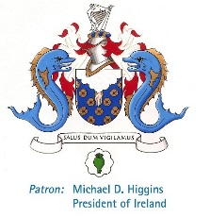
Photographs of this form are not accepted. Please post your completed form to:
The College of Anaesthesologists, 22 Merrion Square North, Dublin 2 OR email a scanned pdf of it to exams@coa.ie
Please tick which Centre: Dublin Kuala Lumpur
Are you a Malaysian trainee? Yes No
Please complete the form in block capitals or in typed format
Course Name: MCAI OSCE/SOE Revision Course – 22nd Oct 2019 (Dublin), 28th April 2019 (Malaysia)
Registration Fee: €290
College ID: _______________
Date Membership MCQ Passed: _______________
Name: _________________________ Surname: ____________________________________________
Address line 1: _____________________________________________________________________________________
Address line 2: _____________________________________________________________________________________
Address line 3: _____________________________________________________________________________________
Town/City: __________________________ Country: ____________________________________________
Mobile number (including country code): ____________________________________________
Email Address: (block letters)

Current post and hospital: _____________________________________________________________________________
Dietary requirements: _____________________________________________________________________________
Please charge my credit card: Visa MasterCard Total Remittance:

Card number: |  |  |  |  | - |  |  |  |  | - |  |  |  |  |  | - |  |  |  |  |  |  | Expiry Date

Security Code: (last three numbers on the back of credit card)

Cardholder’s signature: ____________________ Cardholder’s Name: _______________________
Date: ____________________
Please note 50% of the course fee will be charged if written cancellation is received in the college more than 21 days prior to the course commencing. Delegates cancelling after this date will NOT be entitled to a refund unless the College considers there to be exceptional circumstances that would warrant a refund

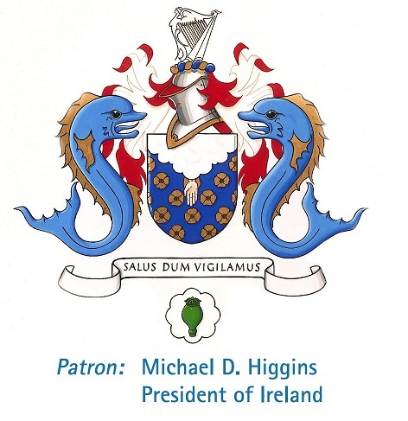

MCAI OSCE/SOE Revision Course

Date: Tuesday, 22nd October (Dublin)

Time: 8:30am to 4:30 pm (approx.)

Venue: TBC

Course Fee: €290 (includes lunch)

Availability: Early booking is advised as there are a limited number of places available.

Co-ordinator: Dr. Caitriona Murphy

MCAI OSCE/SOE Revision Course

Date: Sunday 28th April (Malaysia)

Time: 14:00pm to 17:00 pm (approx.)

Venue: ANZCA ASM 2019 Kuala Lumpur, Malaysia-Room 403 KLCC

Course Fee: €290 (includes Refreshments)

Availability: Early booking is advised as there are a limited number of places available.

Co-ordinator: Dr Crina Burlacu

