Annual Congress of Anaesthesiology & Intensive Care Medicine 2019

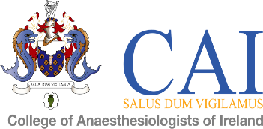

Annual Congress Poster Presentation Competition

May 9th & 10th, 2019
Croke Park

ABSTRACT FORM

Title
Author(s)
Presenter
Name/Address of Institution
Phone
Email

Abstracts to include description of study methods, results and conclusions - Maximum 250 words.
Please see submission guidelines for more details.

Closing date for submission of abstract Monday 18th March 2019. Please return abstract by email to ica2019eposters@coa.ie
Closing date for submission of poster will be April 8th 2019.

Please write abstract here:

