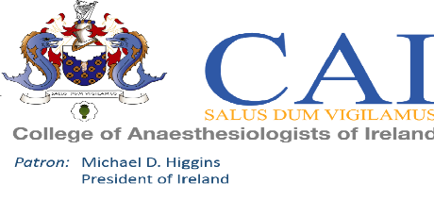
Please complete this form in BLOCK CAPITALS using BLACK INK
This form should be returned to:
The College of Anaesthetists of Ireland, 22 Merrion Square North, Dublin 2 or emailed to rkilcoyne@coa.ie

Name of meeting: | A-CRISIS Simulation Workshop – Friday 18th January 2019

Registration Fee: | €150.00
IMC number:

Surname: |  | Forename:

Address line 1:

Address line 2:

Town/City: |  | Country:

Telephone number

Email address:

Payment can be made by cheque, made payable to Intensive Care Society of Ireland or by cash, credit card:

Cheque (Please Tick)

Credit Card (Please Tick)

Please charge my credit card: |  | Visa |  | MasterCard | Total Remittance: | €

Card number: |  |  |  |  | - |  |  |  |  | - |  |  |  |  | -

Expiry date:

Security Number (Last three numbers on back of credit card:

Cardholder's signature: |  | Cardholder's name:

