College of Anaesthetists of Ireland

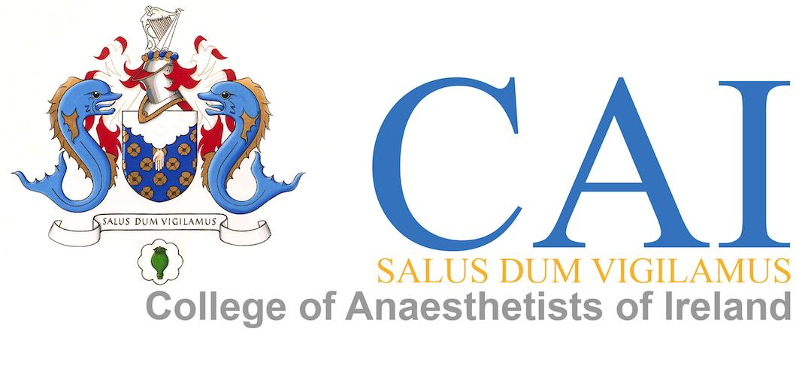
Vascular Access Workshop
Monday 15th January 2018

Venue: Spencer Hotel, IFSC, Dublin 1

Programme

The main focus of this workshop will be on Central Venous Access

10.00am Registration

Session 1 10.30am – 11.30am
Lecture Theatre:
- History of Central Venous Access
- Indications and Uses
- Patient Preparation
- Anatomical Options
- Techniques and Equipment
- Current Guidelines
- Problem Patients
- Coagulation Concerns
- Complications & management

Break 11.30am – 11.50am

Session 2 11.50am – 1.00pm
Lecture Theatre
Topics will include:
- Paediatric Issues
- Ultrasound-getting the most out of the machine

Lunch 1pm – 2pm

Session 3 2pm – 4pm
Interactive Workstations will include:
Clinical Skills Centre
- Anatomy Demonstrations - surface Anatomy and manikins
- Ultrasound Use for Venous Access
- Equipment
- Paediatric Approaches
- Clinical Tips and Discussion

