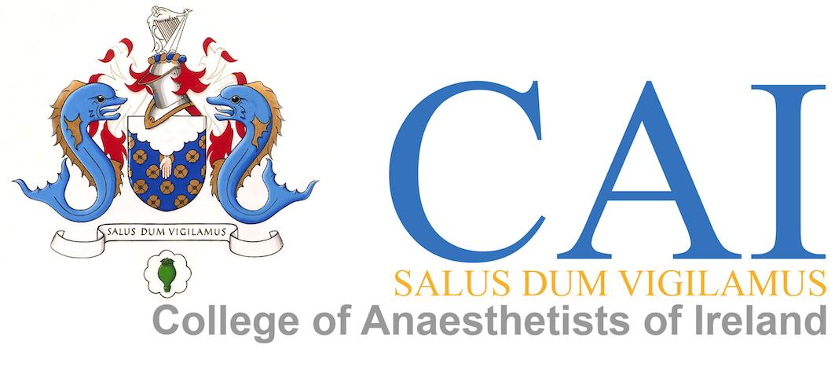

INTRODUCTION TO ANAESTHESIA

Course Programme
Friday 15th June 2018

08.30 – 09.00 R E G I S T R A T I O N (Tea/Coffee)

09.00– 09.20 Welcome & Introduction to SAT Training Programme
Dr Eilis Condon (Deputy Director of Training)

09.20 – 09.40 Overview & Role of the Training Department
Ms. Jennie Shiels (Training Manger)

09.40 – 10.00 EPA – Theory/Background/Application/Practicalities
Dr Eilis Condon (Deputy Director of Training)

10.00 – 10.25 A Day in the life of a SAT Trainee
CAT Member

10.25 – 10.45 B R E A K (Tea/Coffee)

10.45 - 11.30 Resilience
Dr Linda Sissons (HR Lead - HSE Workplace Health & Wellbeing Unit)

11.30 – 12.30 Anaesthesia Machine & Equipment Checks
Mr. Fran Hegarty

12.30 – 13.15 L U N C H

13.15 – 16.15 Interactive Sessions (Clinical Skills Centre)
Interactive Sessions (Clinical Skills Centre)
Delegates are rotated around each station:
- Airway Skills Airways Fellow
- Vascular Access CAT Member
- EPA Demo Dr Eilis Condon
- Simulation Dr Crina Burlacu & Simulation Fellows

16.30 C L O S E

