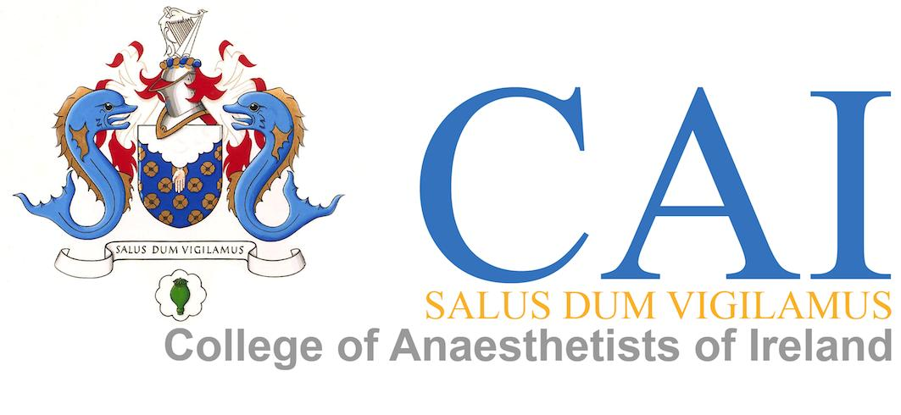

Membership MCQ Examination
- EXAMINATION CALENDER
The Membership MCQ exam is held three times a year in January, June and September. There are exam centres in Dublin, Oman, Jordan and Malaysia. From January 2014 we will also have an exam centre in Egypt. There are three papers to the Membership MCQ exam. The papers consist of 30 multiple choice questions and there is a time of 1 hour allocated for each exam. There is a ten minute break between papers. The exam commences at 9am local time for Dublin. (This time will vary in the other cities)
- LOCAL ARRANGEMENTS
2.1 Premises:
The examination should be held in a convenient venue with reasonably easy access for the candidates. The room should be large enough for a number of well spaced out tables, the number of which will depend on the number of candidates. The tables must be big enough to accommodate each candidate's MCQ Book and Answer Sheet and should be sufficiently separated so that the candidates cannot see each other's papers. There is also a need for one or two candidate waiting rooms and the usual facilities. There should be somewhere reasonably convenient where the candidates can get something to eat and drink – which will be at their own expense. There needs to be a clock present in the room.

  - Candidate Information:

The examinations office needs to be provided with appropriate information regarding the precise examination venue. Signage should be put up in the building where the examination is to be held to guide candidates to the examination room, waiting room and toilets. A timetable of the examination preferably done as a poster, should be displayed thus (the hours shown in this example are the usual time but do not apply to all centres)

MEMBERSHIP MCQ EXAM
08:30 Registration
08:45 Opening of Examination Room
09:00 Pharmacology Paper (30 MCQ questions)
10:00 10 Minute Break
10:10 Physiology Paper (30 MCQ questions)
11:10 10 Minute Break
11:20 Clinical Measurement Paper (30 MCQ questions)
12:20 End of Examination

This timetable should be displayed in English and in the national language. It is desirable to have these posters displayed the evening before.
Please note that candidates need to be told when 30 minutes and 55 minutes have elapsed.

- HOST DUTIES

  - MCQ Papers:
Two weeks prior to the examination, the host is responsible for receiving via DHL, the MCQ books, answer sheets, exam numbers for desks, direction signs and a list of the candidates. We will also send this via email to the host. All DHL packages must be checked and their contents must be confirmed to the sender by the host upon receipt. The packages must be stored securely until the day and time of the examination. The host will take all measures to keep the questions strictly confidential until the start of the examination

  - Supervisor:
The host will supervise the examination in person and will be helped in this task by other supervisors he/she has appointed. The host must be ready to answer questions from the candidates. These usually concern points of clarity of an MCQ or, sometimes, difficulties relating to translation. If a candidates needs to take a break to use the toilet they should be escorted. The examination room should never be left unattended.

  - Set-up and material:
The room selected for the examination needs to be set up with the examination number of each candidate at his or her designation place. The MCQ booklet, answer sheet and a supply of pencils with erasers should also be placed on each candidates designated place and a spare supply of same at the hosts supervising desk. These should be all on the candidates designated area before the candidates enter the room. Only pencil may be used on answer sheets. Any ink pens or markers cannot be used as this interferes with the marking of the answer sheets. Strictly no mobile phones allowed and any bags that have not been left in a designated area prior to arriving at examination room must be left at the top of the examination room

  - Identity check:
The host or appointed supervisor will be supplied with a list of all candidates attending. Each candidate is asked to bring with them their photo ID (passport/driver’s license or ID card) and their letter issued by the College of Anesthetists of Ireland confirming their acceptance to the exam. As candidates arrive their identity must be checked against the list before they enter into the examination room.

  - Collection of papers:
Following each exam all MCQ books and answer books will be collected before the next paper is distributed. Answer sheets should not be placed into the MCQ booklets. This procedure is repeated after each paper.

  - Return of Answer Sheets and MCQ booklets:
The host or supervisor should pack all the MCQ booklets and the Answer Sheets and return them via DHL to The Examinations Office, College of Anesthetists of Ireland, 22 Merrion Square North, Dublin 2, Ireland. An email should be sent to the examinations office from the host to confirm that the package has been couriered. In return an email will be issued from the college to confirm receipt. MCQ books may not be retained. They must ALL be returned.

4.0 RESULTS

Candidates will be advised of their results within one week of taking the examination. The initial passlist will be posted to The College of Anesthetists website (www.anaesthesia.ie) and following from that each candidate will receive a letter confirming their results with a breakdown of the three papers.

