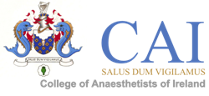
Please complete the form in block capitals or in typed format
This form should be returned to:
The College of Anaesthetists, 22 Merrion Square North, Dublin 2 or emailed to aharte@coa.ie

Course Name: MCAI OSCE/SOE Revision Course 28th February 2015
Registration Fee: €290
College ID: _______________
Date Membership MCQ Passed: _______________
Name: _________________________ Surname: ____________________________________________
Address line 1: _____________________________________________________________________________________
Address line 2: _____________________________________________________________________________________
Address line 3: _____________________________________________________________________________________
Town/City: __________________________ Country: ____________________________________________
Mobile number (including country code): ____________________________________________
Email Address: _____________________________________________________________________________________

Current post and hospital: _____________________________________________________________________________
Dietary requirements: _____________________________________________________________________________

Payment can be made by euro cheque, made payable to The College of Anaesthetists of Ireland or by credit card (see below)
Please charge my credit card: Visa MasterCard Total Remittance:
Card number: |  |  |  |  | - |  |  |  |  | - |  |  |  |  |  | - |  |  |  |  |  |  | Expiry Date

Security Code: (last three numbers on the back of credit card)

Cardholder’s signature: ____________________ Cardholder’s Name: _______________________
Date: ____________________
Please note 50% of the course fee will be charged if written cancellation is received in the college more than 21 days prior to the course commencing. Delegates cancelling after this date will NOT be entitled to a refund unless the College considers there to be exceptional circumstances that would warrant a refund

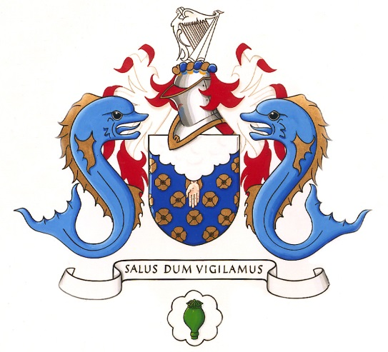

MCAI OSCE/SOE Revision Course

Date: 28th February 2015

Venue: CAI, 22 Merrion Square North, Dublin 2

Course Fee: €290 (includes lunch)

Availability: Early booking is advised as there are a limited number of places available.

Co-ordinator: Dr. Ehtesham Khan

